Please Help Us Provide Holiday Meals for Needy Veterans

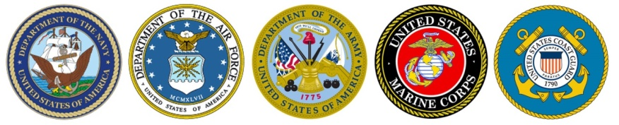

For the past five years, prior to Thanksgiving and the subsequent holiday season, the Rotary Club of Shady Brook in Langhorne has solicited funds outside three super markets, with 100% of the monies raised then used to purchase grocery gift cards to provide holiday meals for local veterans in need.
With the help of hundreds of generous McCaffrey’s, Shop-Rite and Colonial Farms shoppers, we have raised more than $7,500 and provided meals for more than 125 families.
This year, however, the COVID-19 pandemic has made such in-person collection initiatives neither practicable nor advisable. With more veterans and their family members having lost jobs, the need is even greater. Our membership is doubly committed to assisting these men and women who unselfishly volunteered and served our country.
If you would like to help our Rotary Club to continue supporting needy veterans and their families, please donate to: The Rotary Club of Shady Brook – Meals for Veterans.
Your Generous Donation in Any Amount Will Make a Huge Difference for a Local Veteran and His or Her Family!!!

A donation of $50.00 will provide a complete holiday meal for a family of four.

Even donations as small as $5.00 can add up to help us to provide grocery gift certificates with which a veteran can purchase a holiday meal for their family.

Checks can be mailed to: Rotary Club of Shady Brook, P.O. Box 688, Langhorne, PA 19047.

Thank you for your support, and we wish you a Happy Holiday Season!

The Rotary Club of Shady Brook, a 501(c)(3) entity, is a local chapter of Rotary International, a non-sectarian organization endeavoring to bring people from all walks of life together to provide humanitarian services, encourage high ethical standards in all endeavors and pursuits, and help build goodwill and peace in the world. More information on the Rotary Club of Shady Brook and the many programs it supports is available at www.rotaryclubofshadybrook.com.

